

A Project Report On

**Student Management System**

**By**

**Kajal kumari**

**Batch:** 2021-6526

Enrollment no. - EBEON1221503449

**Center: Bangalore**

Under the Guidance of,

**Chittaranjan Ghosh.**

**Technical Trainer**

**EduBridge**

(School of coding)

## Introduction:

The student management system is a simple yet complete management project. Java programming language are its core elements for its completion. Also, this project uses the SQLite database as backend support for storing the course information. In order to run this project, you will require NetBeans IDE and SQLite database viewer.

The name quite explains the scenario of this management system project. That is the purpose of this project. The major task of this project is to store the student’s record. You will provide the details of each and every section of the data fields. So that the system can store your accurate information. There are basically two sections in this project i.e. they are the students and apply for the course in Edubridge learning Pvt Ltd. Into the student section, you can just only access the student details. Here, you will have to provide his/her personal details . And into the student’s section, you have to provide the details of the students. Here the major works are done by the admin. He can add and delete the student.

* The **Student Management System Project in Java** is developed using Java Programming Language.
* The Student Management System Project in Java and MySQL is simple and basic level small project for learning purposes.
* Also, you can modify this system as per your requirements and develop a perfect advance level project.
* A Student Management System Java Code allows you to keep the student records and manage them when needed. This is a simple java project with a good and interactive-looking GUI.
* This Project Use MySQL Database for managing all the data that store in the database.

**Student Management project description:**

Student can manage student records, the information of the students, record of the student, Subject details ETC. Student can add new records as well as can view the details of all the records.Student can open account/close account/check information/View students.Student can open account/close account/check information /View apply for the course.Student can open account/close account/check information / check user information.Student can open account/close account/check information /View department of the students

. **Modules:-**

* Student Management User
* Student Information

The main objective of the student management system is to apply course to the student. It is difficult and time-consuming to collect all student details from each student. To avoid this problem, we have planned to develop a web-based student management system. In Student management user, student can add the (enrollment number, batch id, enrollment course amount, department, and change password, type of student, Logout). He/she can also check the information of the student users at present in the website.

* It manages the details of student records, courses apply department, type of student of the learning based in EduBridge Learning Pvt Ltd.
* Saves the student registration report.
* This system makes all student management apply course & registration.

Student Management User: Student can able to handle recruiter portal and student portal. It provides access to the Recruiter for uploading new course as well as to track the process of apply course application with a username and password.

Student Information: Student can access this website by signing up. Student can apply course for student from his portal as well as he/she can update job portal for student .Students can view the course applied by Edubridge learning Pvt Ltd., Students can apply for course, Students can view the course applied by themselves, Students can change the password as well as Student can update profile.

**Software Requirements:**

**Front end:** Core Java Technology/J2EE

**Back end**: MySQL workbench 8.0 CE.

**Tools to be Used: \*** Use any IDE to develop the project. It may be Eclipse/My eclipse etc.

* MySQL for the database.

**Operating System:** Window 10

Data Dictionary:

Create database Student Management System

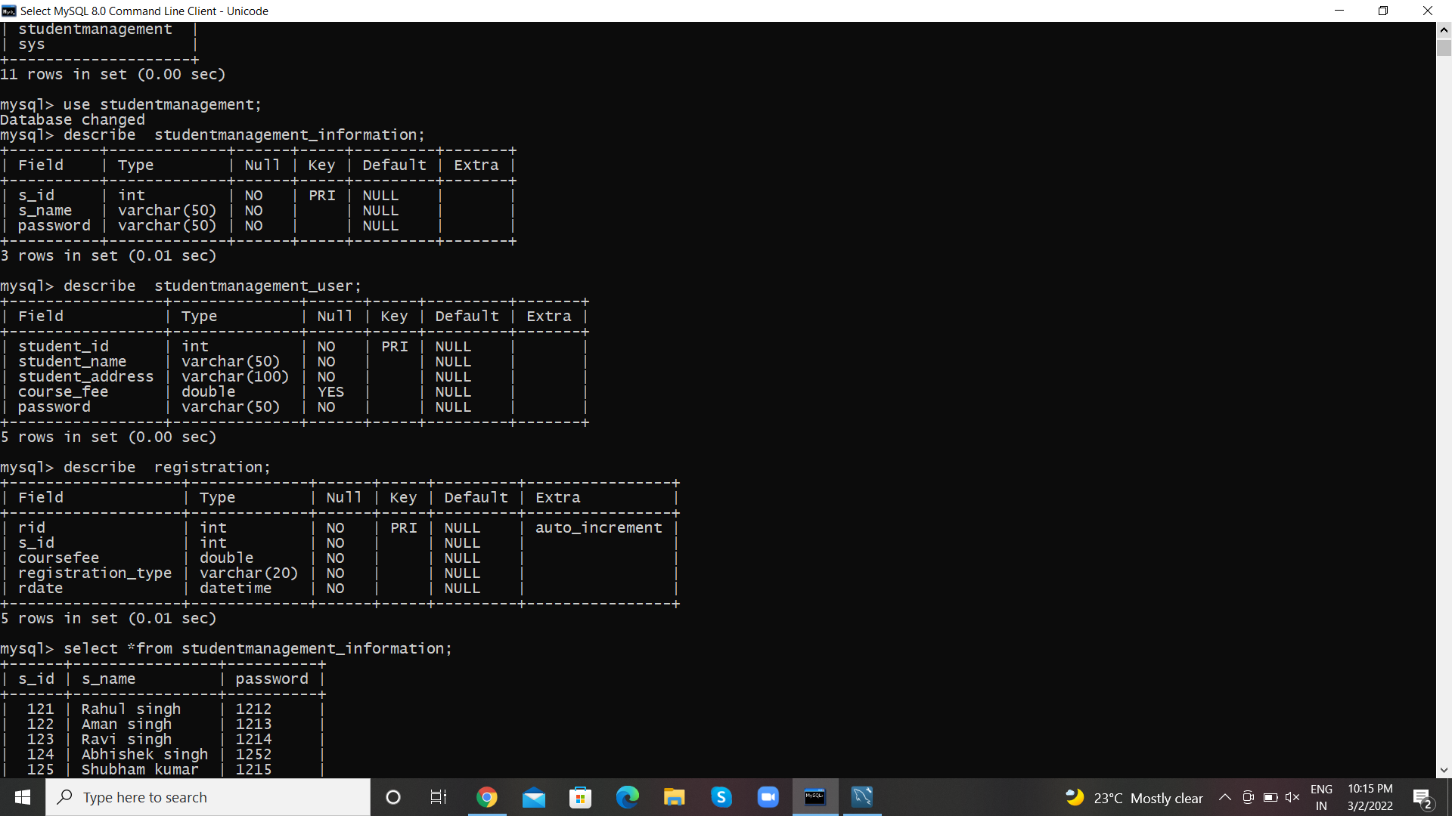

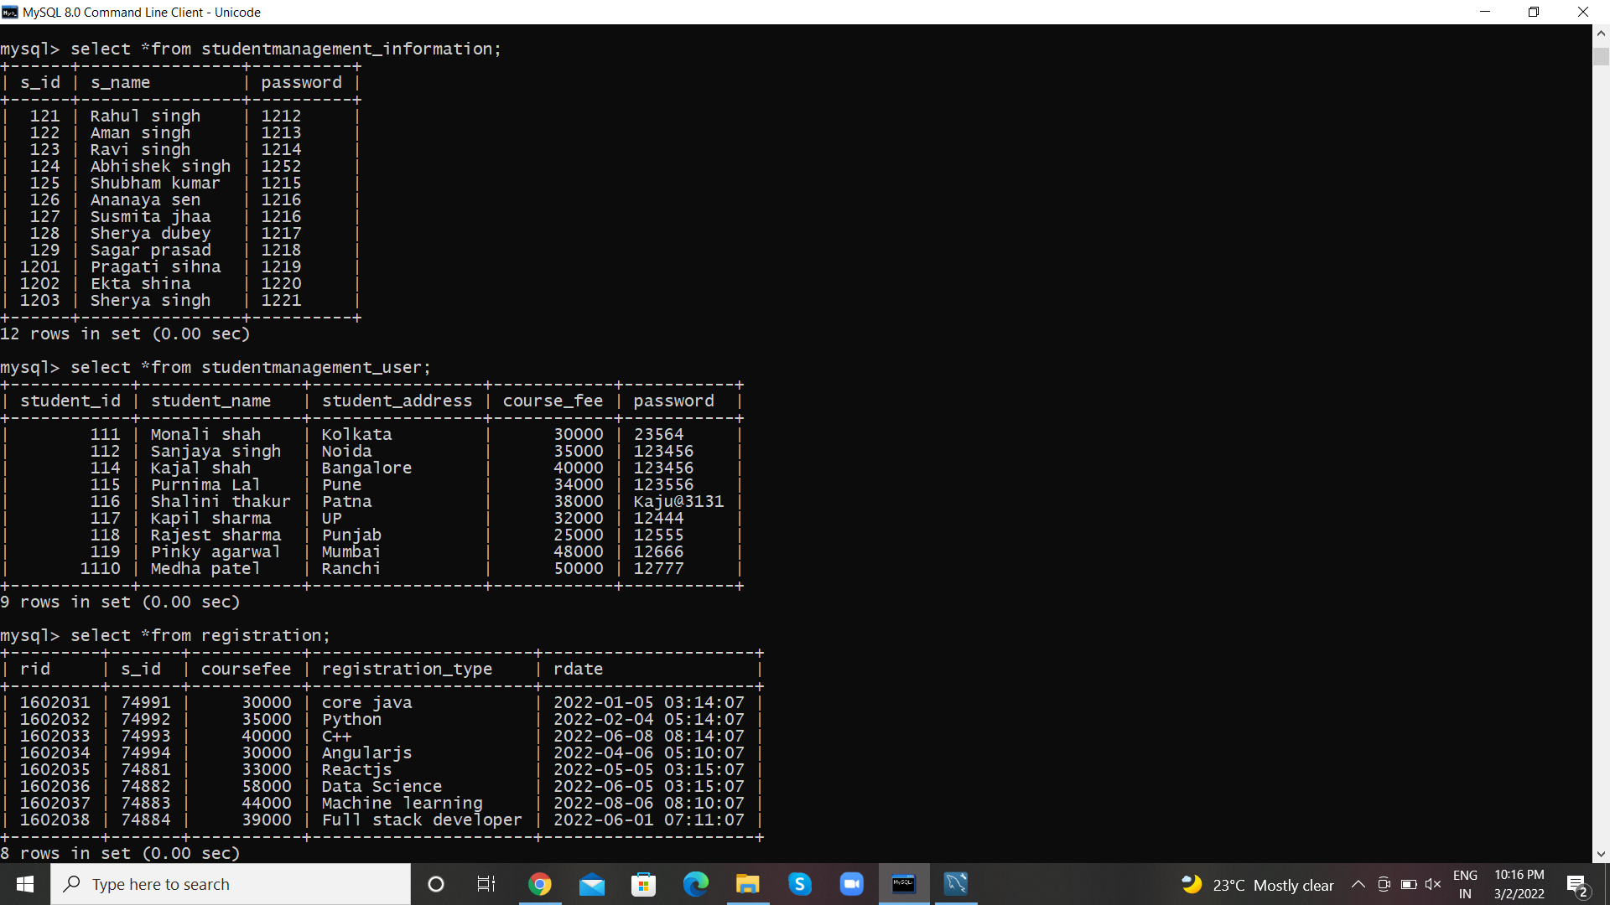

**About the Student Management System in Java**

**Project Name:** Student Management System

**Languages used:** JAVA

**Database:** MySQL

**Type:** Desktop Application

**Developer:** IT SOURCECODE

**Updates:** 0

**SUMMARY**

The **Student Management Systems Project in Java** built fully in Java and MySQL Database. It has full-featured Graphical User Interface (GUI) with all the functionalities. This Article is the way to enhance and develop our skills and logic ideas which is important in practicing the Java programming language which is most well known and most usable programming language in many company.

The project is about managing all the student applied for the course record. It also check the user information the key call of the project is to incorporate different parts of the course department in a coherent way such that complicated task can be managed by either all the details of the course .

THANK YOU